**Git Module 2, Assignment 3**

**To Do :**

● Create a git working directory, with the following branches ○ Develop ○ F1 ○ f2

● In the master branch, commit main.txt file

● Put develop.txt in develop branch, f1.txt and f2.txt in f1 and f2 respectively

● Push all these branches to github

● On local delete f2 branch

● Delete the same branch on github as well

**Solution :**

//Created a new Virtual Machine.

Mkdir asst3

Cd asst3

touch main.txt

git init

git remote add origin [git@github.com:sinhatushar17/AsstSelf.git](mailto:git@github.com:sinhatushar17/AsstSelf.git) //Connecting to github (SSH).

git remote –v //AsstSelf.git 🡪 Remote repo set successfully

cd /out of asst3 dir.

cd .ssh

ssh-keygen (pressed enter 3 times) //Generating key pair

ls // authorized_keys id_rsa id_rsa.pub -available

cat id_rsa.pub //now after entering this cat code "Public Key" was generated.

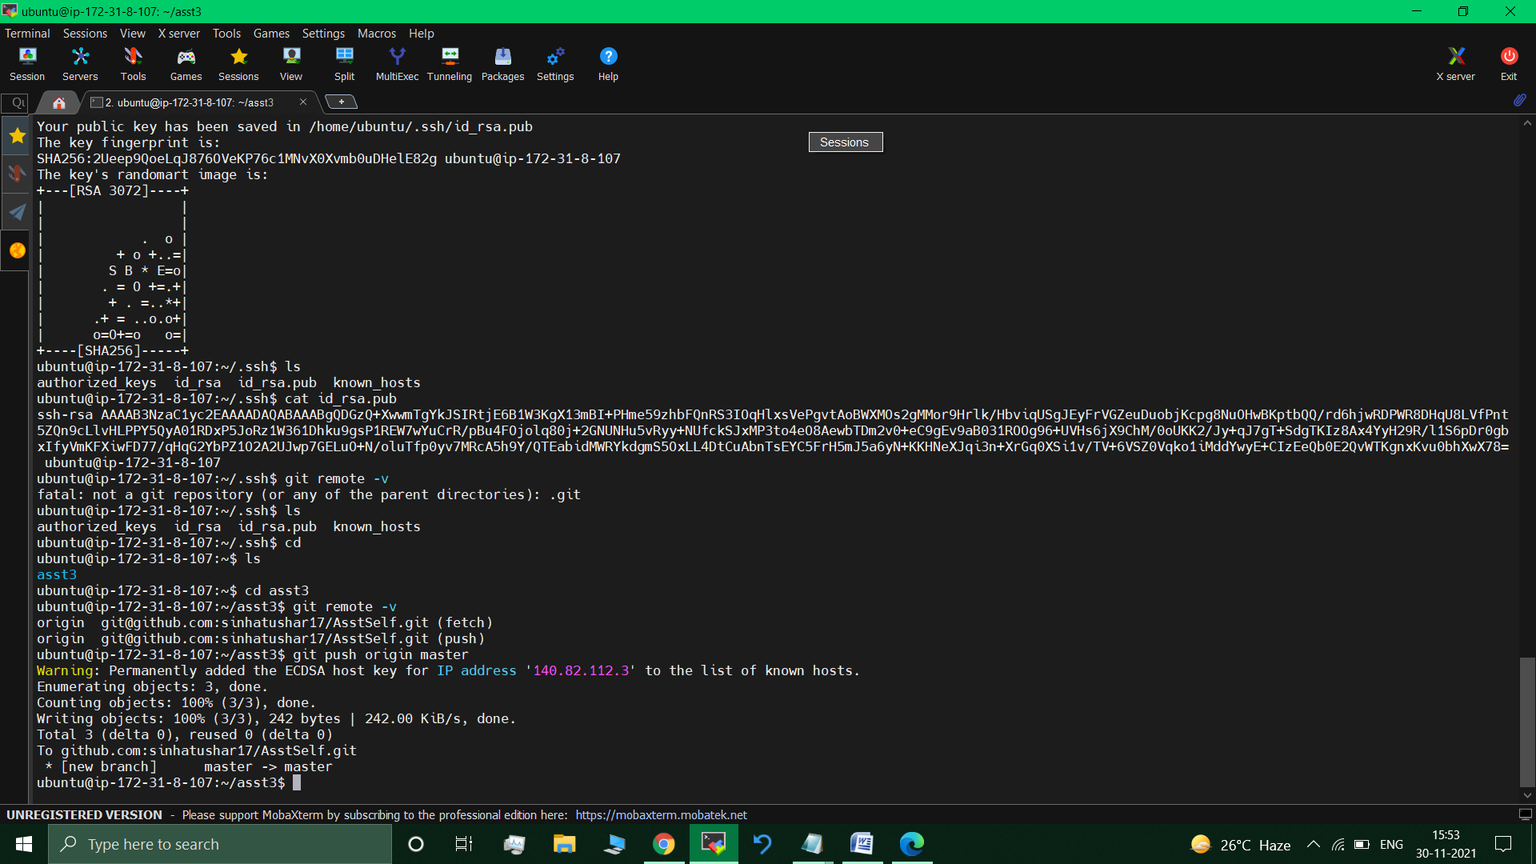

//we have to paste this Public Key on github, So that our authentication method is proper.

-> going to github profile >settings >ssh and gpg keys>new ssh key >Pasted the ssh key.

git add main.txt

git commit -m "added main.txt to master branch"

git branch Develop

git branch F1

git branch f2 // All required branches created.

git branch //Develop ,F1 ,f2 branches present.

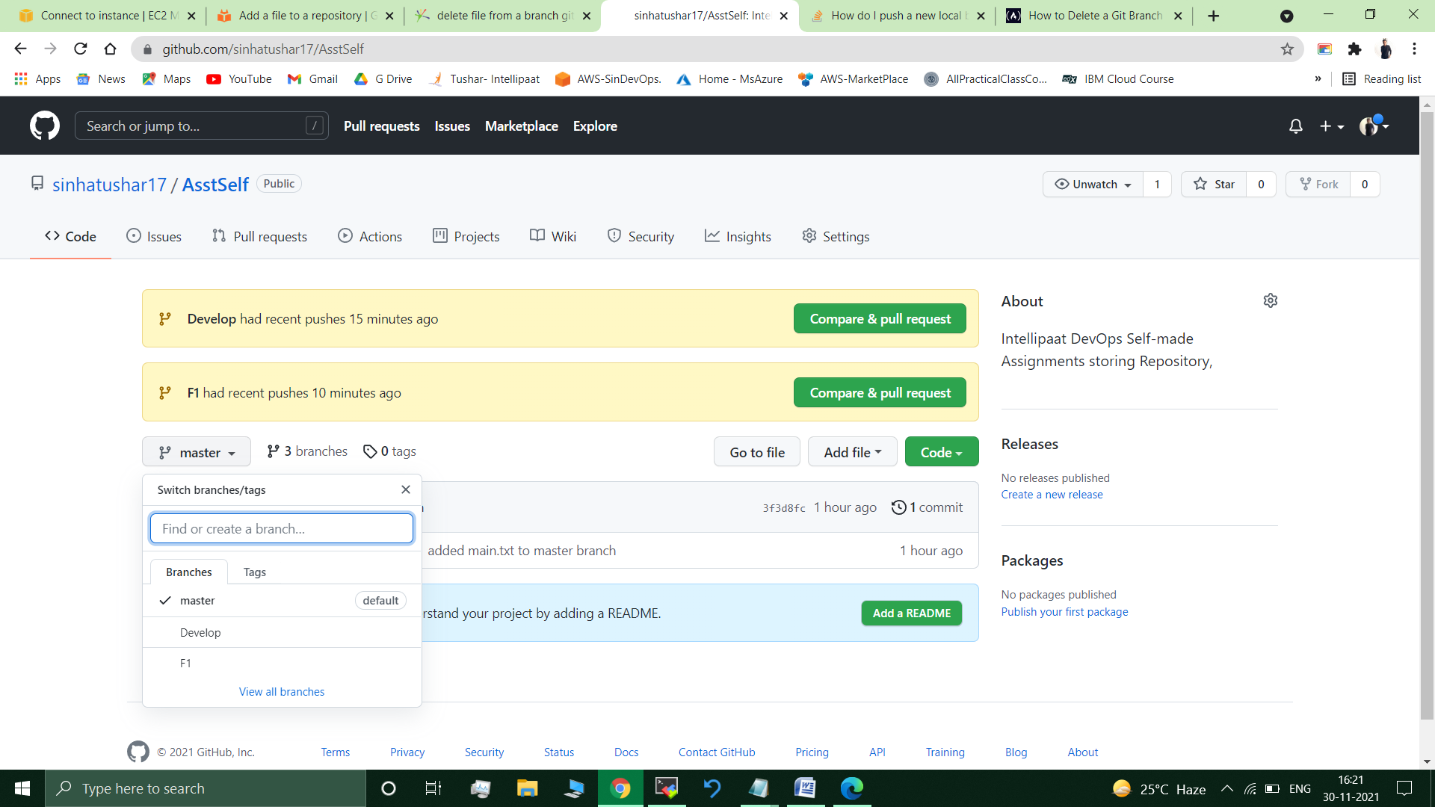

git checkout Develop //Switched to branch 'Develop'

touch develop.txt //put or created a develop.txt according to step number 3 of the assignment question.

git checkout F1

touch F1.txt

git checkout f2

touch f2.txt //All txt files sent to their required branches.

git push origin master //Pushed files to our repo, now verifying on github in my "AsstSelf" Repository - one file present i.e. Main.txt //

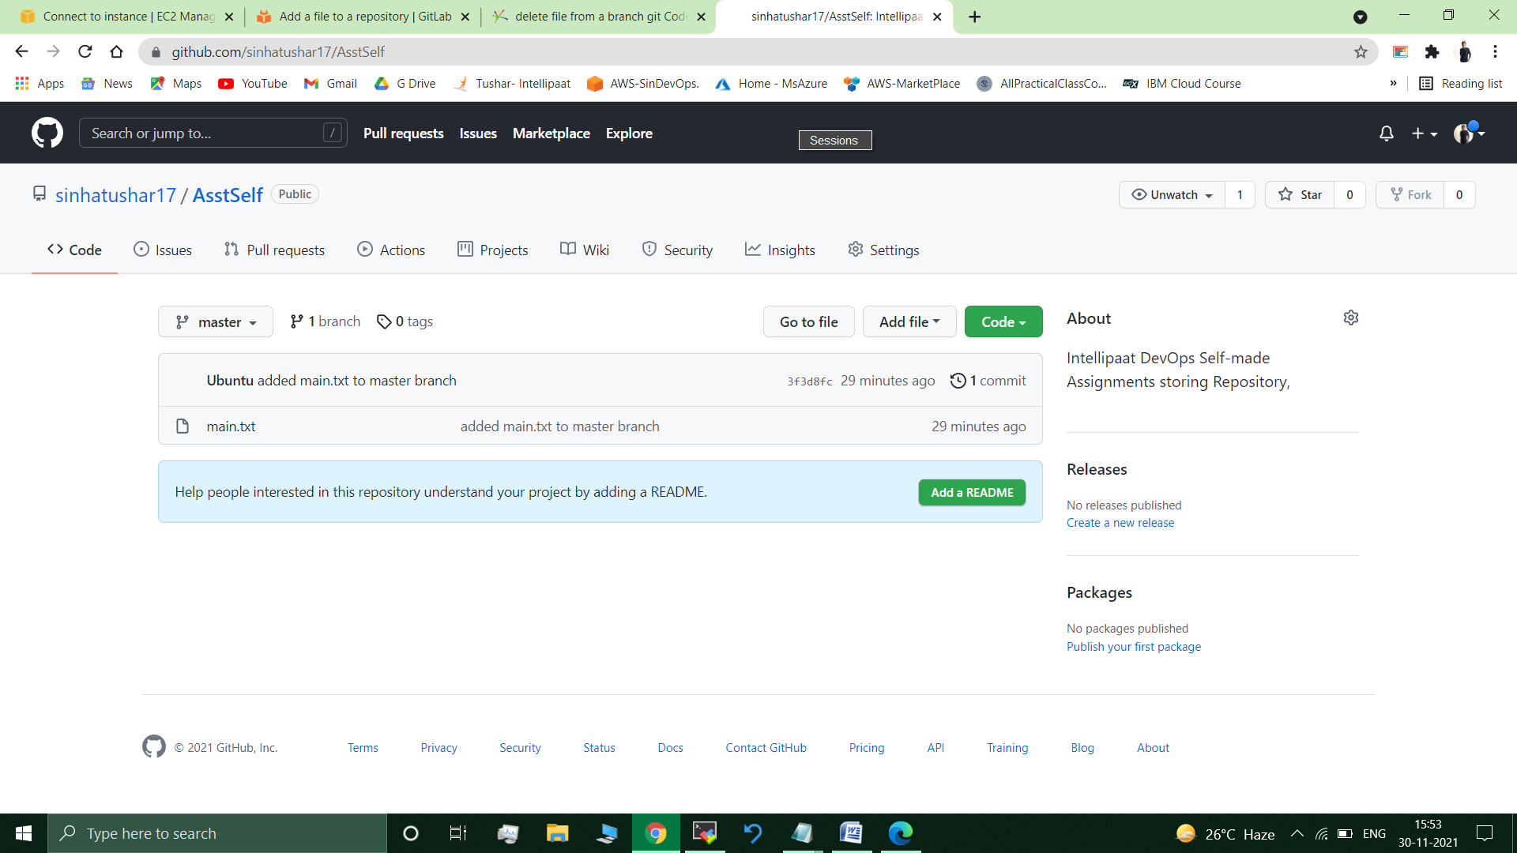

git checkout Develop //switched to Develop branch

git add develop.txt

git commit -m "added develop.txt to Develop branch"

git push origin Develop // develop.txt added to Develop branch in github repository

git checkout F1

git add f1.txt

git commit -m "F1.txt added to F1 branch"

git checkout f2

git add f2.txt

git commit -m "f2.txt added to F1 branch" // All files pushed to their respective branches. 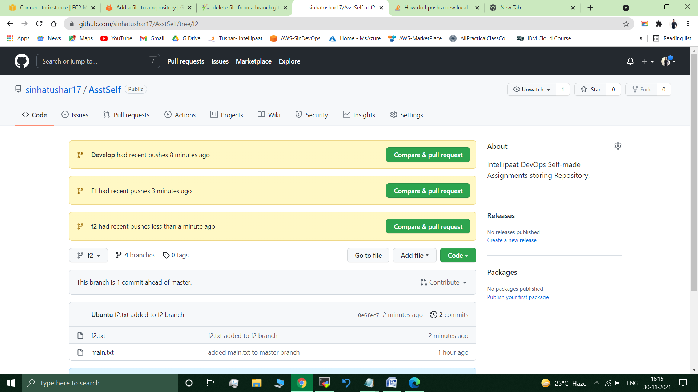

git branch -D f2 //Deleted f2 branch locally.

git push origin --delete f2 //Deleted the f2 Branch Remotely i.e. from git also the f2 branch has been deleted.

**Submitted By : Tushar Sinha**

**Email ID :** [**sinhatushar17@gmail.com**](mailto:sinhatushar17@gmail.com)

**Enrolled in the “DevOps Architect Master’s Training Program”**